

**Alin Calin**

Dutu

**CONTACT**

Nationality: Romanian Gender: Male

# EDUCATION AND TRAINING

**23 SEP 2019 – CURRENT** – Str. Splaiul Independentei, nr. 313, Sector 6, Bucharest, Romania



## University License

Polytechnic University of Bucharest

**Field(s) of study**

* Information and Communication Technologies: *Computer use | Software and applications development and analysis | Inter-disciplinary programs and qualifications involving Information and Communication Technologies (ICTs)*
* Computer programming (C, Java, Python, x86 Assembly)
* Education: *Education science Teacher training with subject specialization Inter-disciplinary programs and qualifications involving education*
* Engineering, manufacturing and construction: *Electronics and automation Electricity and energy*
* Generic programs and qualifications: *Basic programs and qualifications*

[upb.ro](http://upb.ro/)

**15 SEP 2015 – 23 MAY 2019** – Str. Henri Coanda, nr. 21, Ramnicu Valcea, Romania

## High School Diploma

Matei Basarab National College of Computer Science

**Field(s) of study**

* Generic programs and qualifications: *Basic programs and qualifications*
* Information and Communication Technologies: *Computer use | Database and network design and administration | Information and Communication Technologies (ICTs) not further defined*
* Natural sciences, mathematics and statistics: *Natural sciences, mathematics and statistics not further defined*
* Computer programming (C++, SQL, HTML)
* <http://cnimateibasarab.ro/>

**6 MAY 2015 – 20 MAY 2015**

## Certificate of completion

Hour of Code

**Field(s) of study**

* Information and Communication Technologies: *Software and applications development and analysis*
* Computer programming using blocky method [code.org](http://code.org/)

## Level II Diploma

Mouse Academy

* Learning to use Microsoft Office

*1 / 3*

* Learning to use the Internet
* Learning Computer components

**Field(s) of study**

* Generic programs and qualifications: *Basic programs and qualifications*
* Information and Communication Technologies: *Computer use*

**24 NOV 2016 – 6 JUN 2018** – 56, Bd. Dacia, Sector 2, Bucharest, Romania

## ECDL Profile Certificate - ECDL Profile BAC

ECDL Foundation [www.ecdl.ro](http://www.ecdl.ro/)

The Old Schools, Trinity Ln, Cambridge, United Kingdom

## Cambridge English Level 2 Certificate in ESOL International (Advanced)

Cambridge Assessment English

**Field(s) of study**

* English Language [cambridgeenglish.org](http://cambridgeenglish.org/)

# LANGUAGE SKILLS

**MOTHER TONGUE(S):** Romanian

## English

Listening

**C1**

Reading

**C1**

Spoken production **C1**

Spoken interaction **C1**

Writing

**C1**

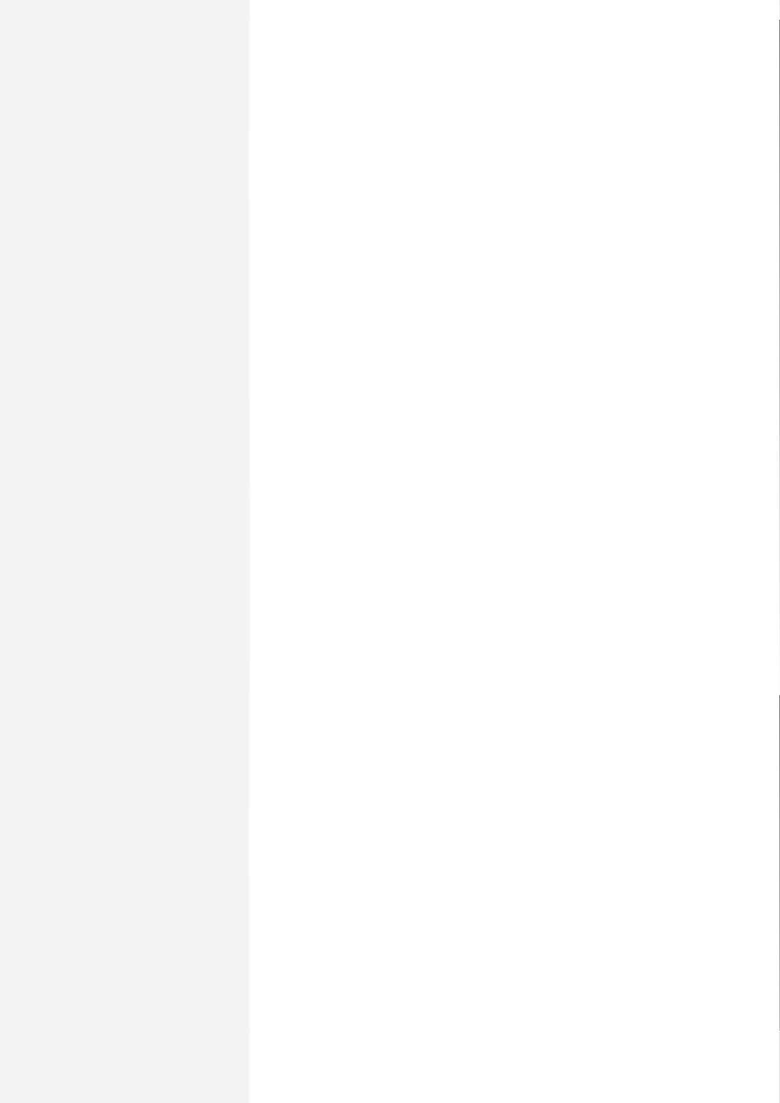

# COMMUNICATION AND INTERPERSONAL SKILLS

## Teamwork, Problem Solving



I have worked in various types of teams during my high school courses.

## Intercultural skills

I have taken part in various projects and activities such as Mouse Academy, Hour of Code during which have experienced hand first the advantages of a multicultural environment.

# ORGANISATIONAL SKILLS

## Managerial skills



Whilst participating in numerous activities such as high-school and university projects and extra-curricular activities, I have managed to organize such contests as geography, history and programming projects and follow the leadership of my fellow colleagues.

*2 / 3*

# DIGITAL SKILLS

## Programming Skills

Java Programming language / x86 Assembly / C Programming Language / C++ Programming Language / Programming SQL / Programming language PYTHON / LaTeX (Proficient) / Linux Bash / HTML Basics / Basics of JavaScript

## Using other Applications

GIT (GitHub) / Microsoft Office Suite / Google Suite (Gmail Google Drive Google Slide Google Sheet Google Form Google

## Other skills

Proficient user of Internet / Proficient User of Windows / Proficient user of Android

# DRIVING LICENCE

Driving License: AM / Driving License: B1 / Driving License: B

# HOBBIES AND INTERESTS

## Basketball



A relaxing activity in which reliability, team-working, knowledge and skill are the most important parts of the game. I spent a good part of my time practicing and playing with my friends.

## Technology

I like to get informed about what is new in technology, mostly in the smartphone area. I watch different kind of reviewers from either YouTube, tech blogs or well- known websites such as The Verge, Zona IT and Cavaleria

<https://www.theverge.com/> <https://zonait.ro/> <https://cavaleria.ro/>

Job advertisement link: <https://www.bestjobs.eu/en/job/software-developer-c-java-in-suceava-5293649?rid=f29d2d29-4c79-404b-a980-b7725a596497%3AAPAb7IQWEXYN%2BZQadwXjhr9dYnjZiUlKsA%3D%3D&st=gts&pos=1&list=20>

*3 / 3*